# Lab: Policy Based Management

|  |
| --- |
| * This is an in-class lab, and due **tonight (Feb. 1st)**. Encouraged finishing it during the class. * Use the following naming convention: homework, underscore, last name, first initial, and extension (e.g., Lab_PBM_ImG.docx). * You can use your Windows 2019 VM or Windows VM on the Proxmox Server. * Do not copy any of the sample screenshots provided as illustrations. * This is graded as pass/fail. |

* (**Task1**) Show in a screenshot like above that **usp_MyPolicyTest** stored procedure is created in **MyPolTestDB** successfully. Do your own work and do not copy the screenshot above.

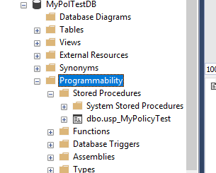

* (**Task2**) Show in a screenshot that **MyPolicyTest** stored procedure cannot be created. Capture the screen showing an error message.

